**Failure Modes and Effects Analysis (FMEA) of Refrigerator**

**System:** Refrigerator

**Function:** Refrigeration is an essential food storage technique in developed countries. The lower temperature lowers the reproduction rate of bacteria, so the refrigerator reduces the rate of spoilage. A refrigerator maintains a temperature a few degrees above the freezing point of water.

**Subsystems:**

1. COMPRESSOR
2. CONDENSOR
3. RECEIVER
4. EXPANSION VALVE
5. EVAPORATOR

**Performed By:** Pritam Sarkar (171210044)

**Submitted to:** Dr. Vivek Shrivastava

**System Description:**

In the refrigeration cycle, there are five basic component and these five components interact with each other and keep the temperature of the food stored in refrigerator cool. Here how they perform their tasks:

1. The compressor constricts the refrigerant vapor, raising its pressure, and pushes it into the coils on the outside of the refrigerator.

2. When the hot gas in the coils meets the cooler air temperature of the kitchen, it becomes a liquid.

3. Now in liquid form at high pressure, the refrigerant cools down as it flows into the coils inside the freezer and the fridge.

4. The refrigerant absorbs the heat inside the fridge, cooling down the air.

5. Last, the refrigerant evaporates to a gas, then flows back to the compressor, where the cycle starts all over.

**System Layout:**

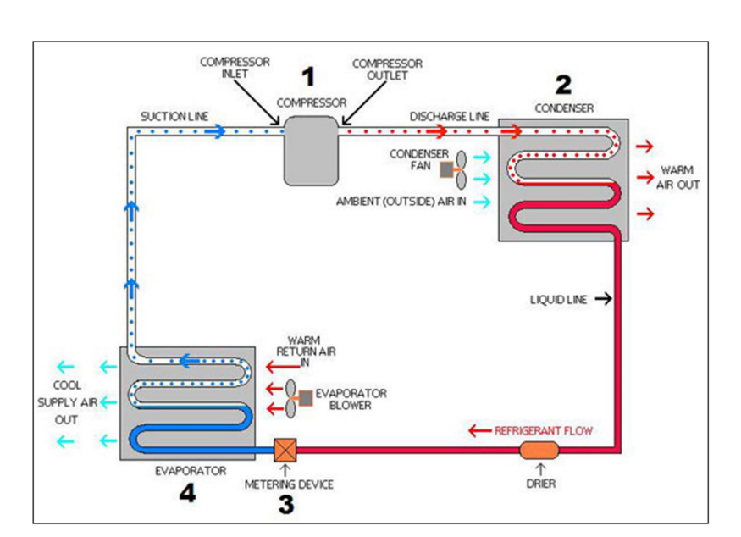

**Reliability Block Diagram:**

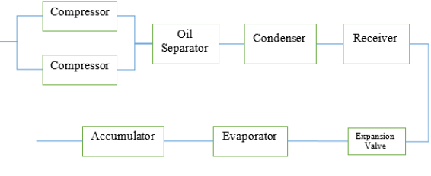

**FMEA Table:**

|  |  |  |  |  |
| --- | --- | --- | --- | --- |
| **SUB SYSTEM** | **FUNCTION** | **FAILURE MODE** | **FAILURE DETECTION** | **EFFECT OF FAILURE** |
| COMPRESSOR | Co/mpress the refrigerant | 1.Seal leaks  2. Oil filter blocked  3. Filter suction blocked | 1. Sight glass for oil level  2. Oil pressure gauge  3. No early  warning | 1.Oil is reduced, It wears out.  2. Oil circulation low, Unit heat  3. Low suction pressure |
| CONDENSOR | Condensing the refrigerant | 1.Filter on water is plugged  2. water pipe blocked by scaling | high pressure gauge | 1.Water cooling is limited, stops working  2. heat exchange is not  Good, overload |
| RECEIVER | Refrigerant storage | Lubricant trapped in  Filter blocked | Analysis | Less storage for refrigerant  Less refrigerant supply into evaporator |
| EXPANSION VALVE | Reducing the pressure of refrigerant | Table – Severity rating scale for | Analysis | Supply refrigerant into evaporator is not efficient |
| EVAPORATOR | Heat absorption | Evaporator fins blocked by ice | Analysis | Circulation of cooling process is not good |

Table – Severity rating scale

|  |  |
| --- | --- |
| SEVERITY | DESCRIPTION |
| 1-2 | Probably not detect failure |
| 3-4 | Minor, low failure |
| 5-6 | Moderate |
| 7-8 | High harmful, caused system down |
| 9-10 | Catastrophic, damage to system and operator |

Table- Occurrence Scale

|  |  |
| --- | --- |
| OCCURRENCE | DESCRIPTION |
| 1 | More than a year |
| 3 | 4-6 months |
| 5 | 1-3 months |
| 7 | Every month |
| 9 | Every time |

Table- Detection Scale

|  |  |
| --- | --- |
| DETECTION | DESCRIPTION |
| 1 | Easily detected |
| 3 | Detected by high prob |
| 5 | Detected by moderate prob |
| 7 | Detected by low prob |
| 9 | Couldn’t be detected |

Table-RPN Value

|  |  |  |  |  |  |
| --- | --- | --- | --- | --- | --- |
| ITEM | S | O | D | RPN | Counteractive Measure |
| Compressor | 9 | 3 | 3 | 81 | Maintenance of compressor so that oils are not leaked and pressure is not reduced. |
| Condenser | 9 | 4 | 4 | 144 | Safety valve can be added so that damage can be prevented earlier. |
| Evaporator | 3 | 9 | 2 | 54 | Ice flower should be cleaned periodically so that fins are not blocked. |
| Receiver | 8 | 2 | 6 | 96 | Filters should be cleaned and valve should be introduced so that leakage is not there. |
| Expansion Valve | 6 | 2 | 3 | 36 | Durability of valve should be increased. |

**Conclusions:**

FMEA approaches is used to identify the cause of the failure and its effect on the refrigerator. the initial stage of FMEA is to establish a boundary system using a reliability block diagram to identify the components to be analyzed in the failure mode. The next stage using FMEA worksheet analysis of possible failure modes, the result of failure and the method to detect failure on the refrigeration component.

Each failure mode is then assessed the level of severity, occurrence and detection to get the value of RPN. The greater RPN value’s, the greater risk that can be caused by modes of failure component that may pose hazards to the system, operator, product or environment.

As we can see from the table that, the high RPN values are obtained due to high values of severity.

Broadly speaking, efforts to reduce risks to the refrigeration system are done by reducing the severity, reducing the rate of occurrence and can be detected easily. by knowing the level of risk on a system then it can determine precise and efficient failure precautions.

**Reference:**

1. Risk Analysis on Refrigeration Unit by Approaching FMEA Model (A case study on fishing vessel)

Muhamad Zaki Latif, Yuniar Endri Priharanto and Rahmad Surya Hadi Saputra